How to fill a hole in the Mesh
10/12/2026
You have deleted a malformed ear on the head and now you find yourself with a giant hole in the mesh. What do you do.
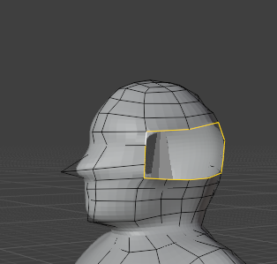
Use the F key to fill the hole after selecting all of the sides
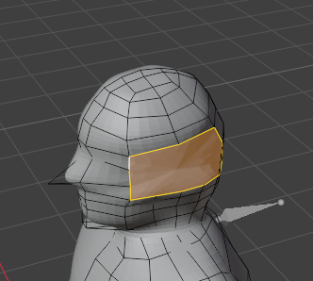
First make sure the number of vertices match between all the surfaces that you want to fill, it that means adding extra edge loops to one side of the hole, then do it.
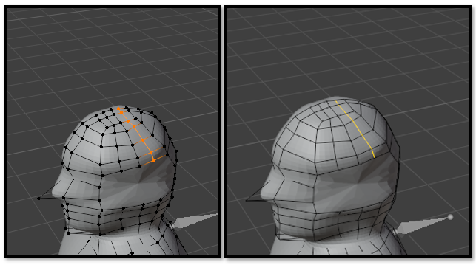
Use the knife tool and start to connect all of the vertices

After adding the cuts, check to see if all of the new edges work when selecting an entire loop cut using shift-alt. And they all see themselves as one merged type of topology. Yea!
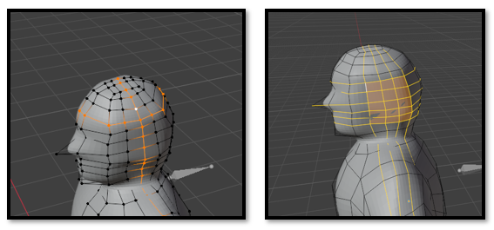
Straighten the Vertices on the head
